Create one VPC in the N. Virginia region.
Phase 1: Custom Network Topology (VPC)
- Create the VPC:
  - Navigate to VPC > Your VPCs > Create VPC.
  - Select VPC only, name it Custom-VPC, and assign IPv4 CIDR: 10.0.0.0/16.
- Deploy the Subnets:
  - Go to Subnets > Create subnet and select Custom-VPC.
  - Public Subnet 1: Name: Public-1, Zone: us-east-1a, CIDR: 10.0.0.0/24.
  - Public Subnet 2: Name: Public-2, Zone: us-east-1b, CIDR: 10.0.2.0/24.
  - Private Subnet: Name: Private-1, Zone: us-east-1b, CIDR: 10.0.1.0/24.
- Establish Internet Entry (IGW):
  - Go to Internet gateways > Create internet gateway (My-IGW).
  - Select it, click Actions > Attach to VPC, and link it to Custom-VPC.
- Configure Public Routing:
  - Go to Route tables > Create route table (Public-RT). Link to Custom-VPC.
  - Click Routes > Edit routes, add Destination: 0.0.0.0/0, Target: Internet Gateway (My-IGW).
  - Click Subnet associations > Edit subnet associations and explicitly check both Public-1 and Public-2.
- Deploy the NAT Gateway:
  - Go to NAT gateways > Create NAT gateway. Name: My-NAT, Subnet: Public-1.
  - Click Allocate Elastic IP, then click Create.
- Configure Private Routing:
  - Go to Route tables > Create route table (Private-RT). Link to Custom-VPC.
  - Click Routes > Edit routes, add Destination: 0.0.0.0/0, Target: NAT Gateway (My-NAT).
Click Subnet associations > Edit subnet associations and check only Private-1.
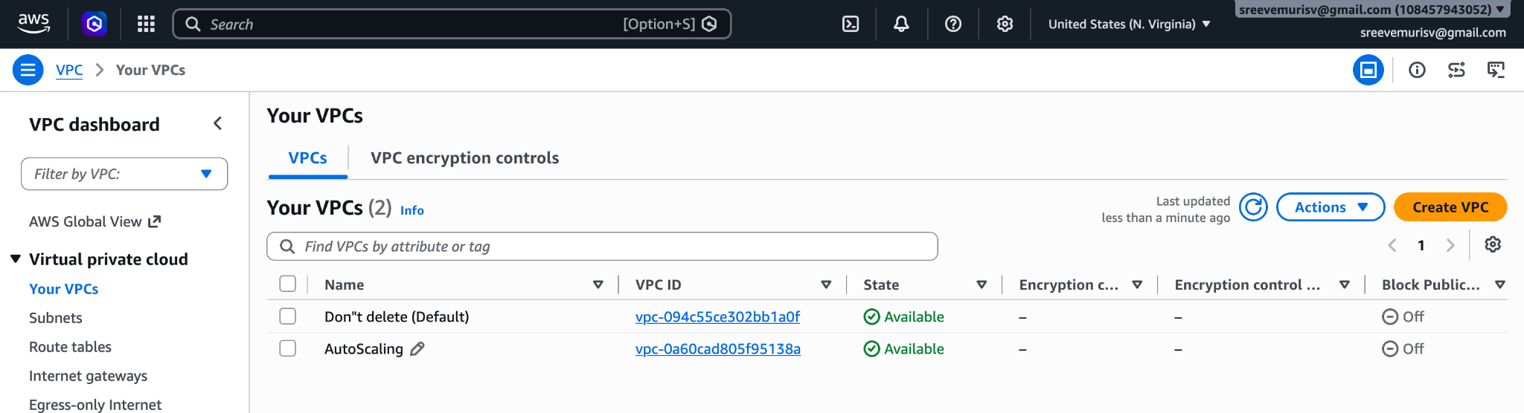
Create two subnets: one public subnet and one private subnet.
Attach an IGW to the VPC.
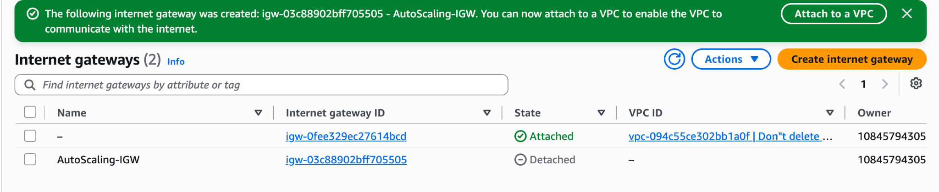
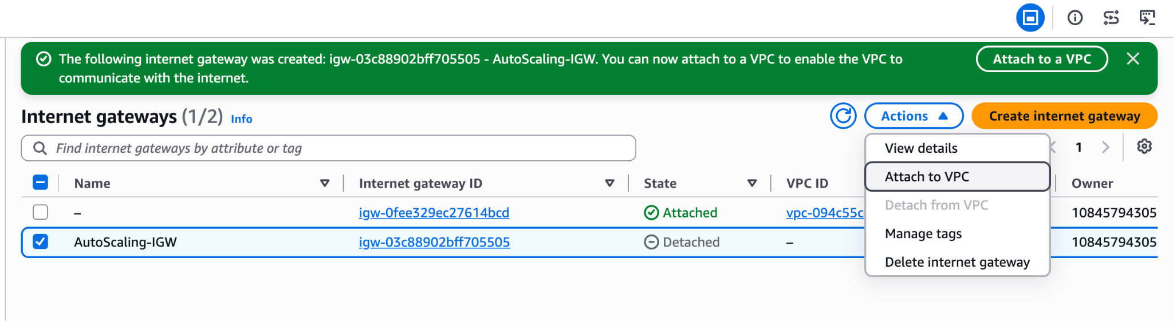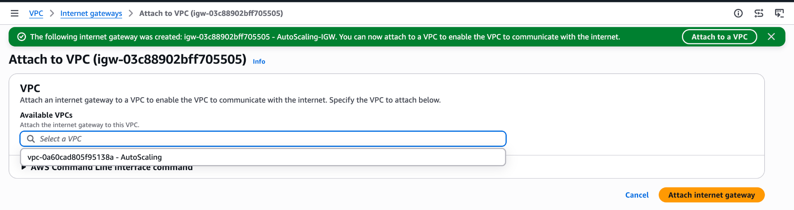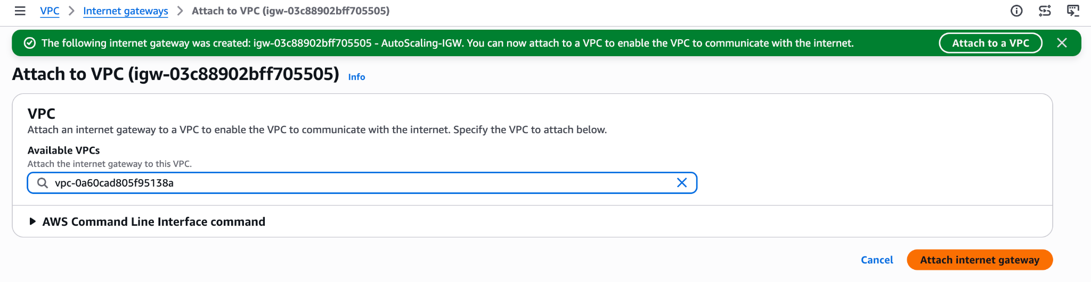
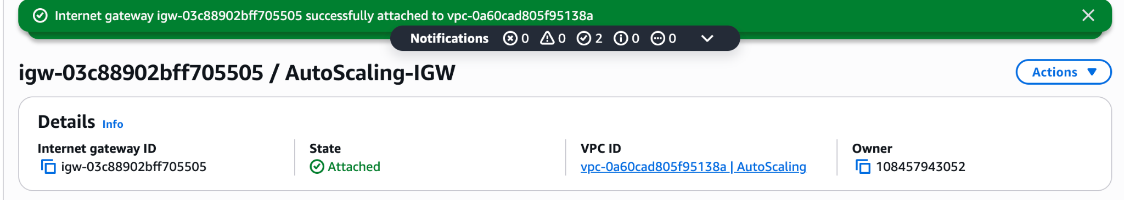
Create one public route table (RT) and one private route table.
Public-AutoScaling RoutTable
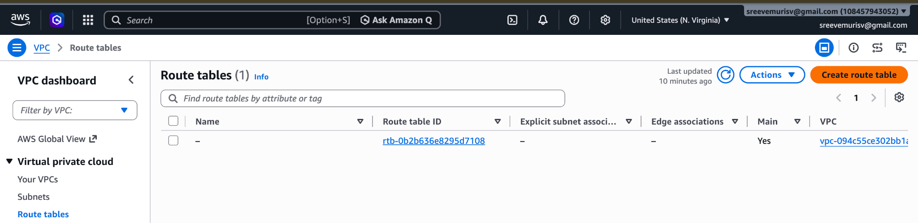
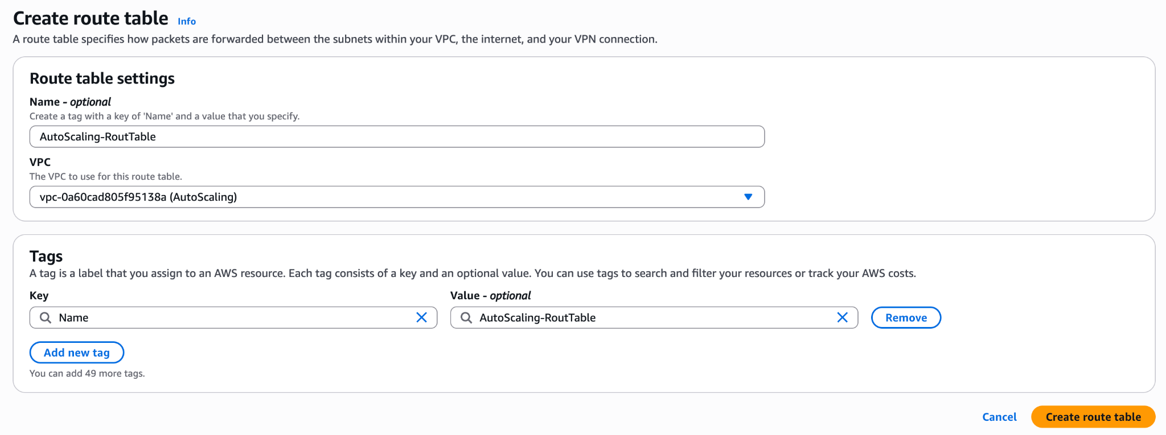
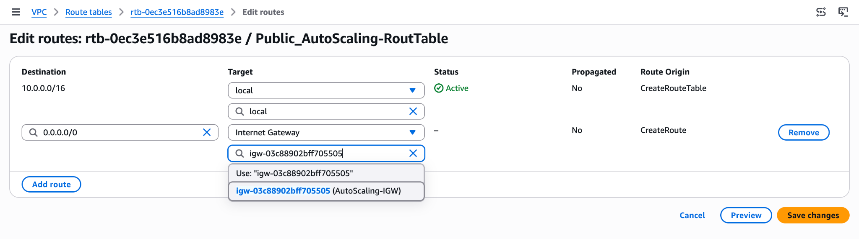
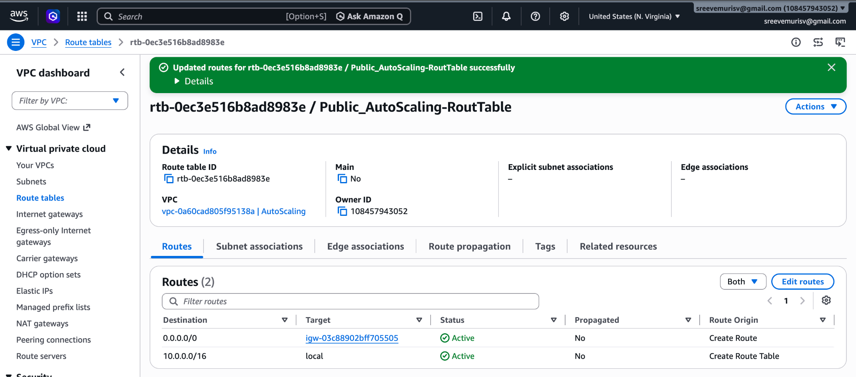
Private-AutoScaling RoutTable
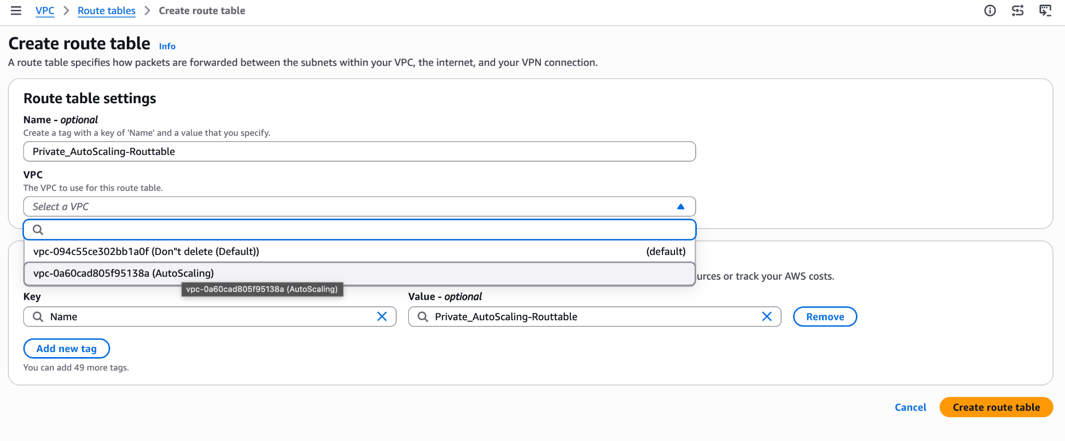
No Need to Edit Rout as it is already a private by default with out IGW given
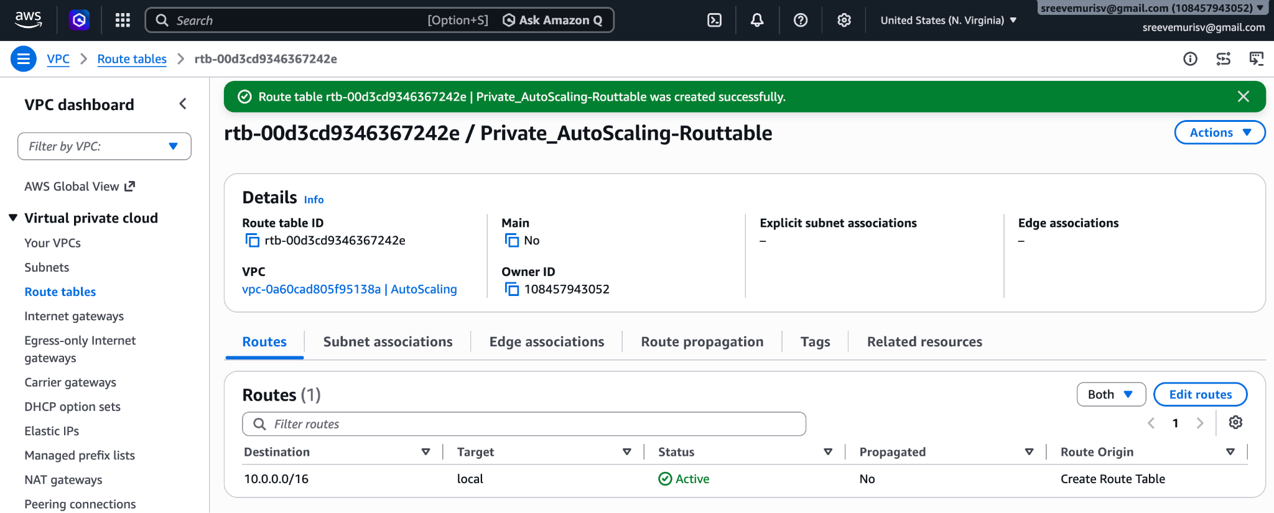
Deploy a NAT gateway in the public subnet and attach the NAT gateway to the private subnet.
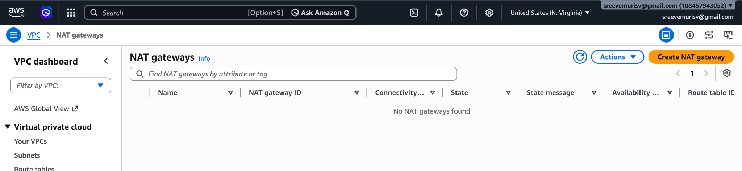
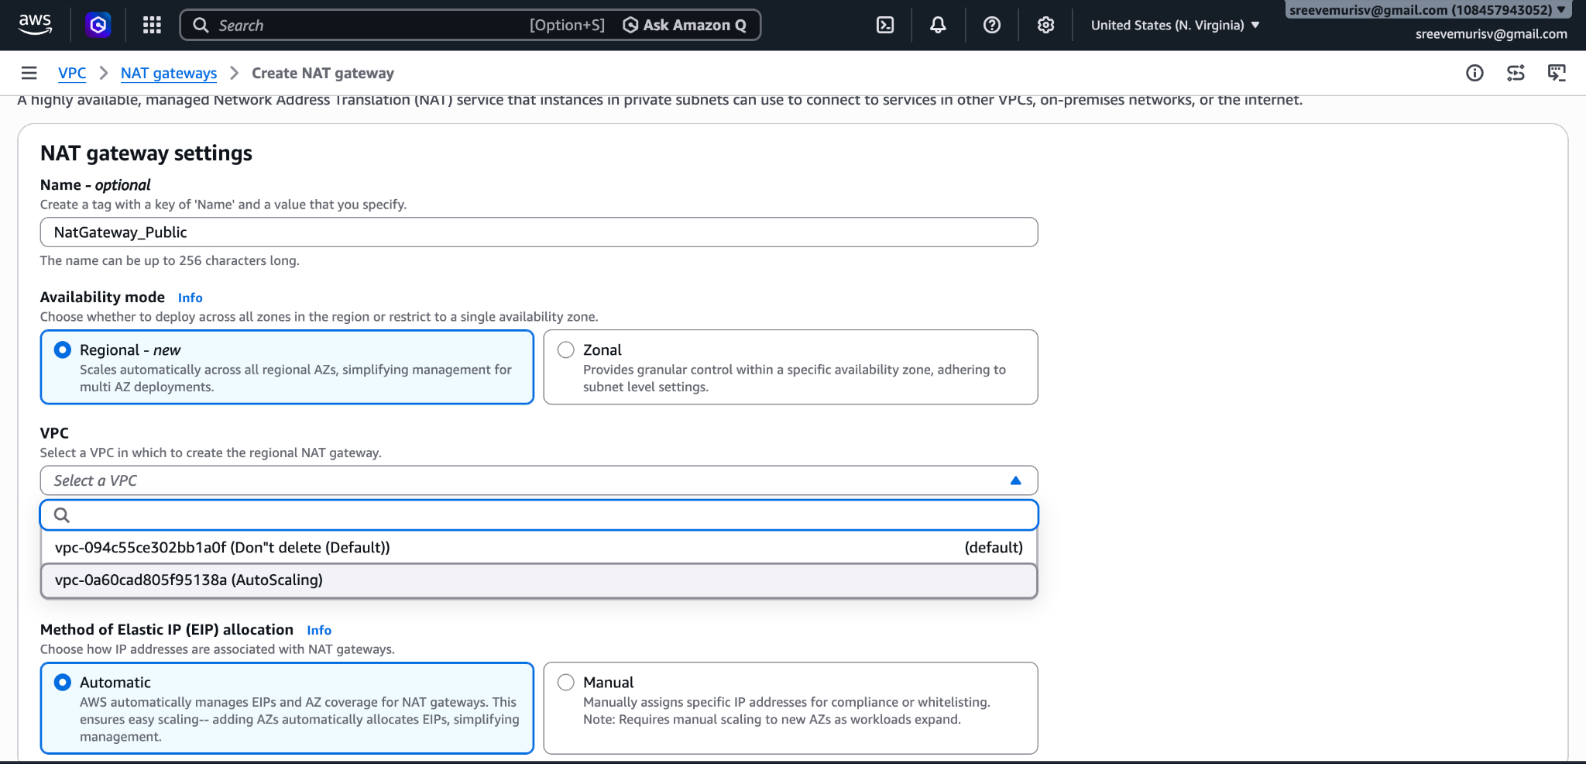
and Click Create NatGateway.
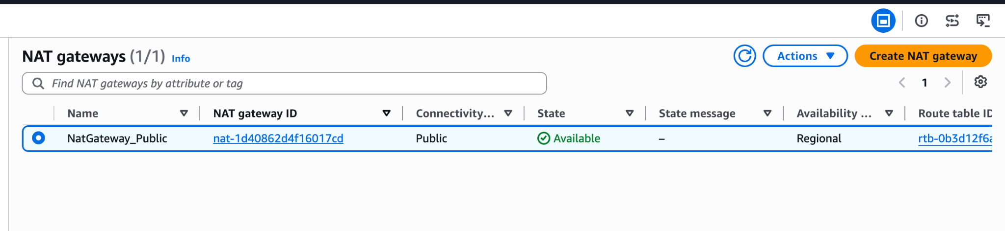
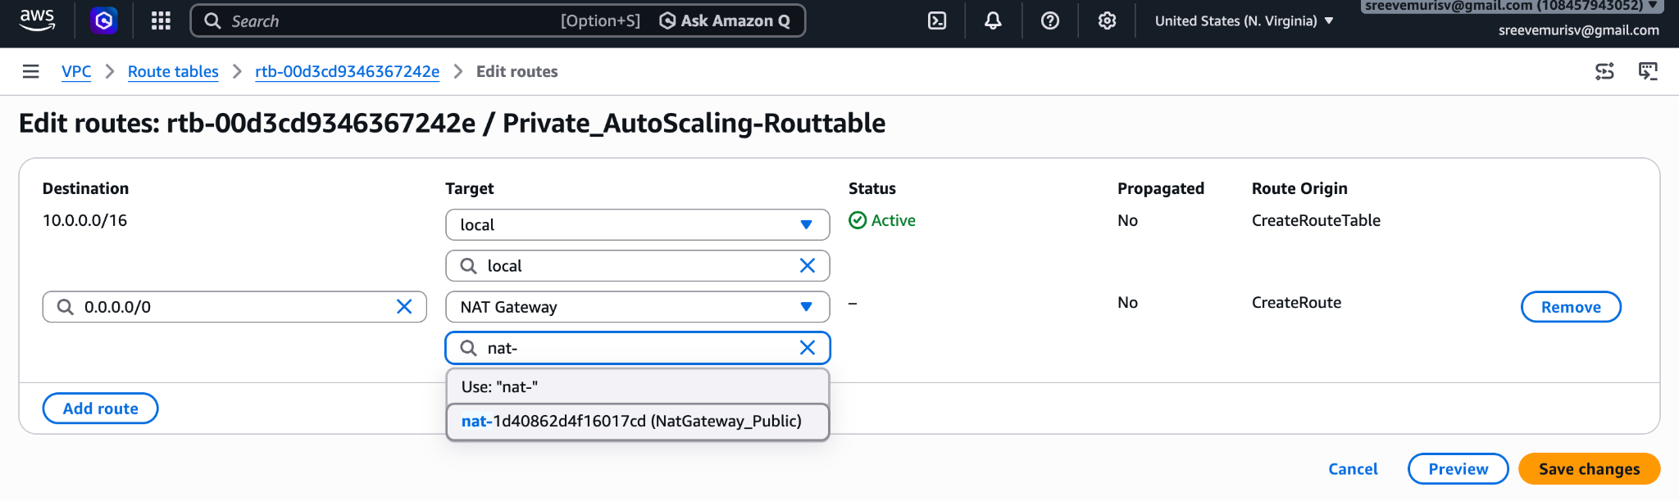
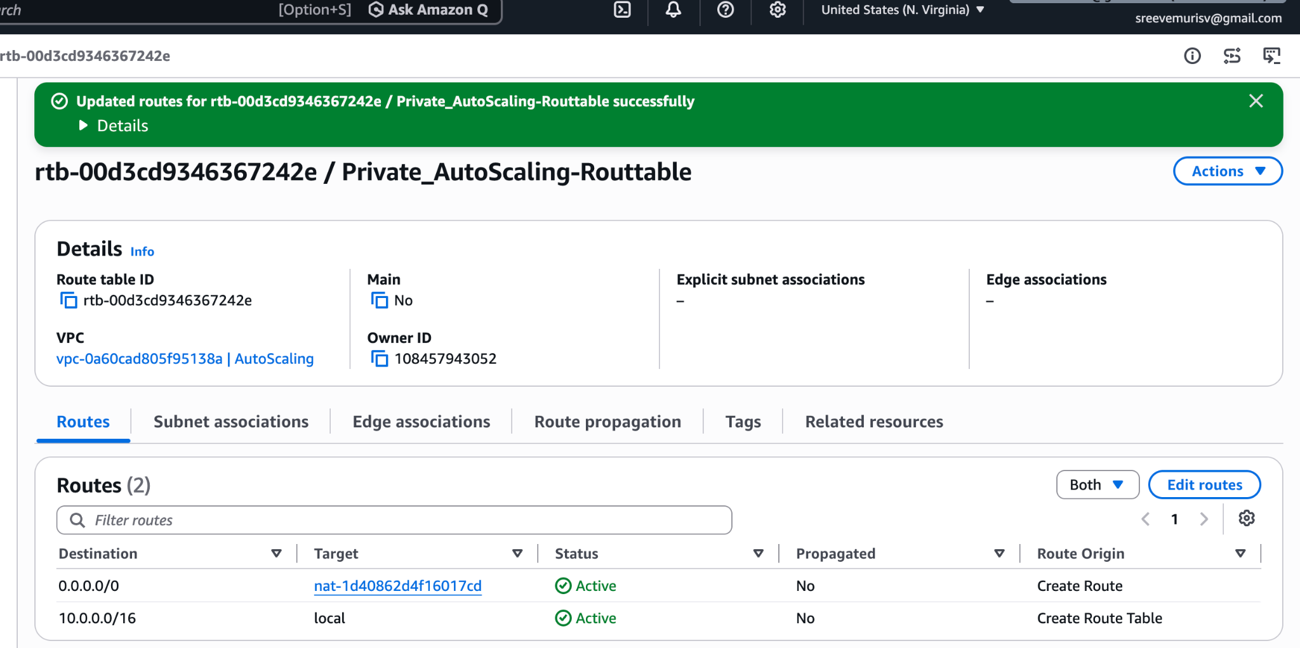
Create two instances, one in the public subnet and one in the private subnet.
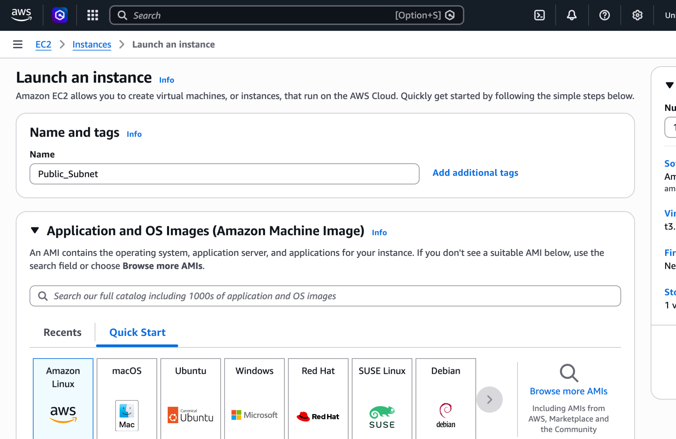
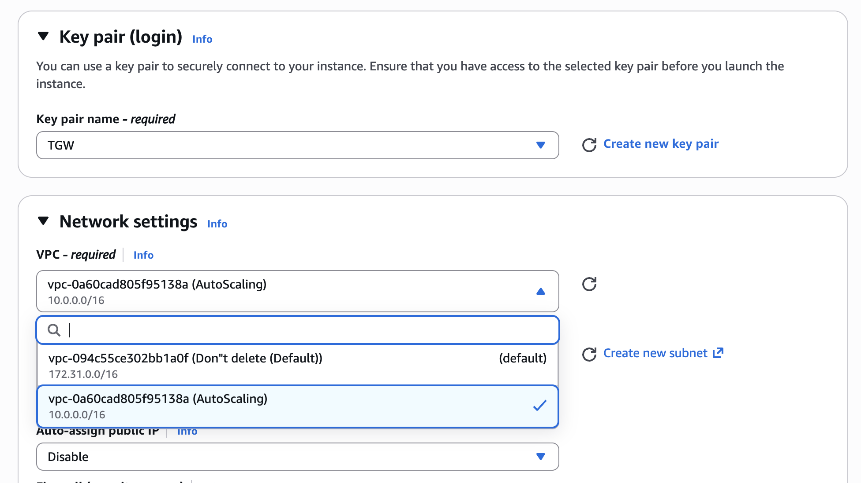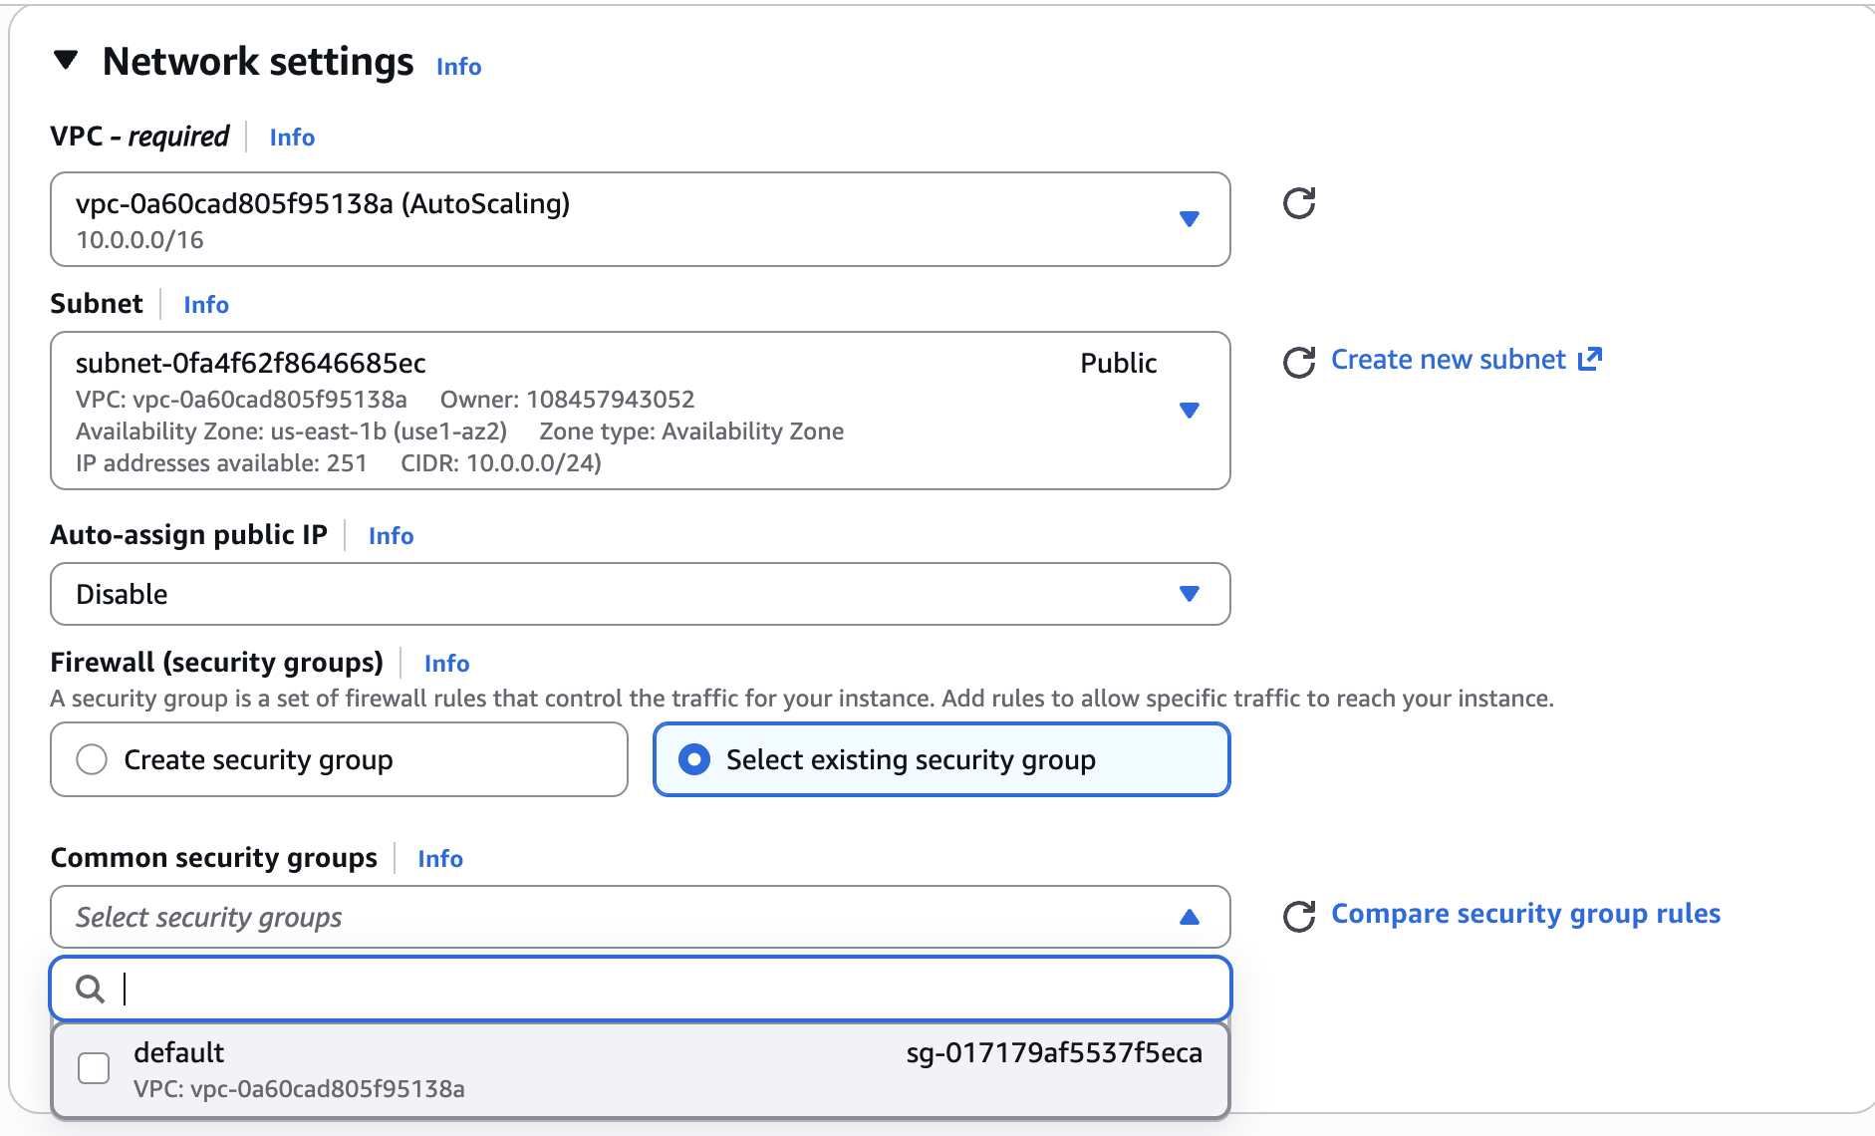
Private_Subent
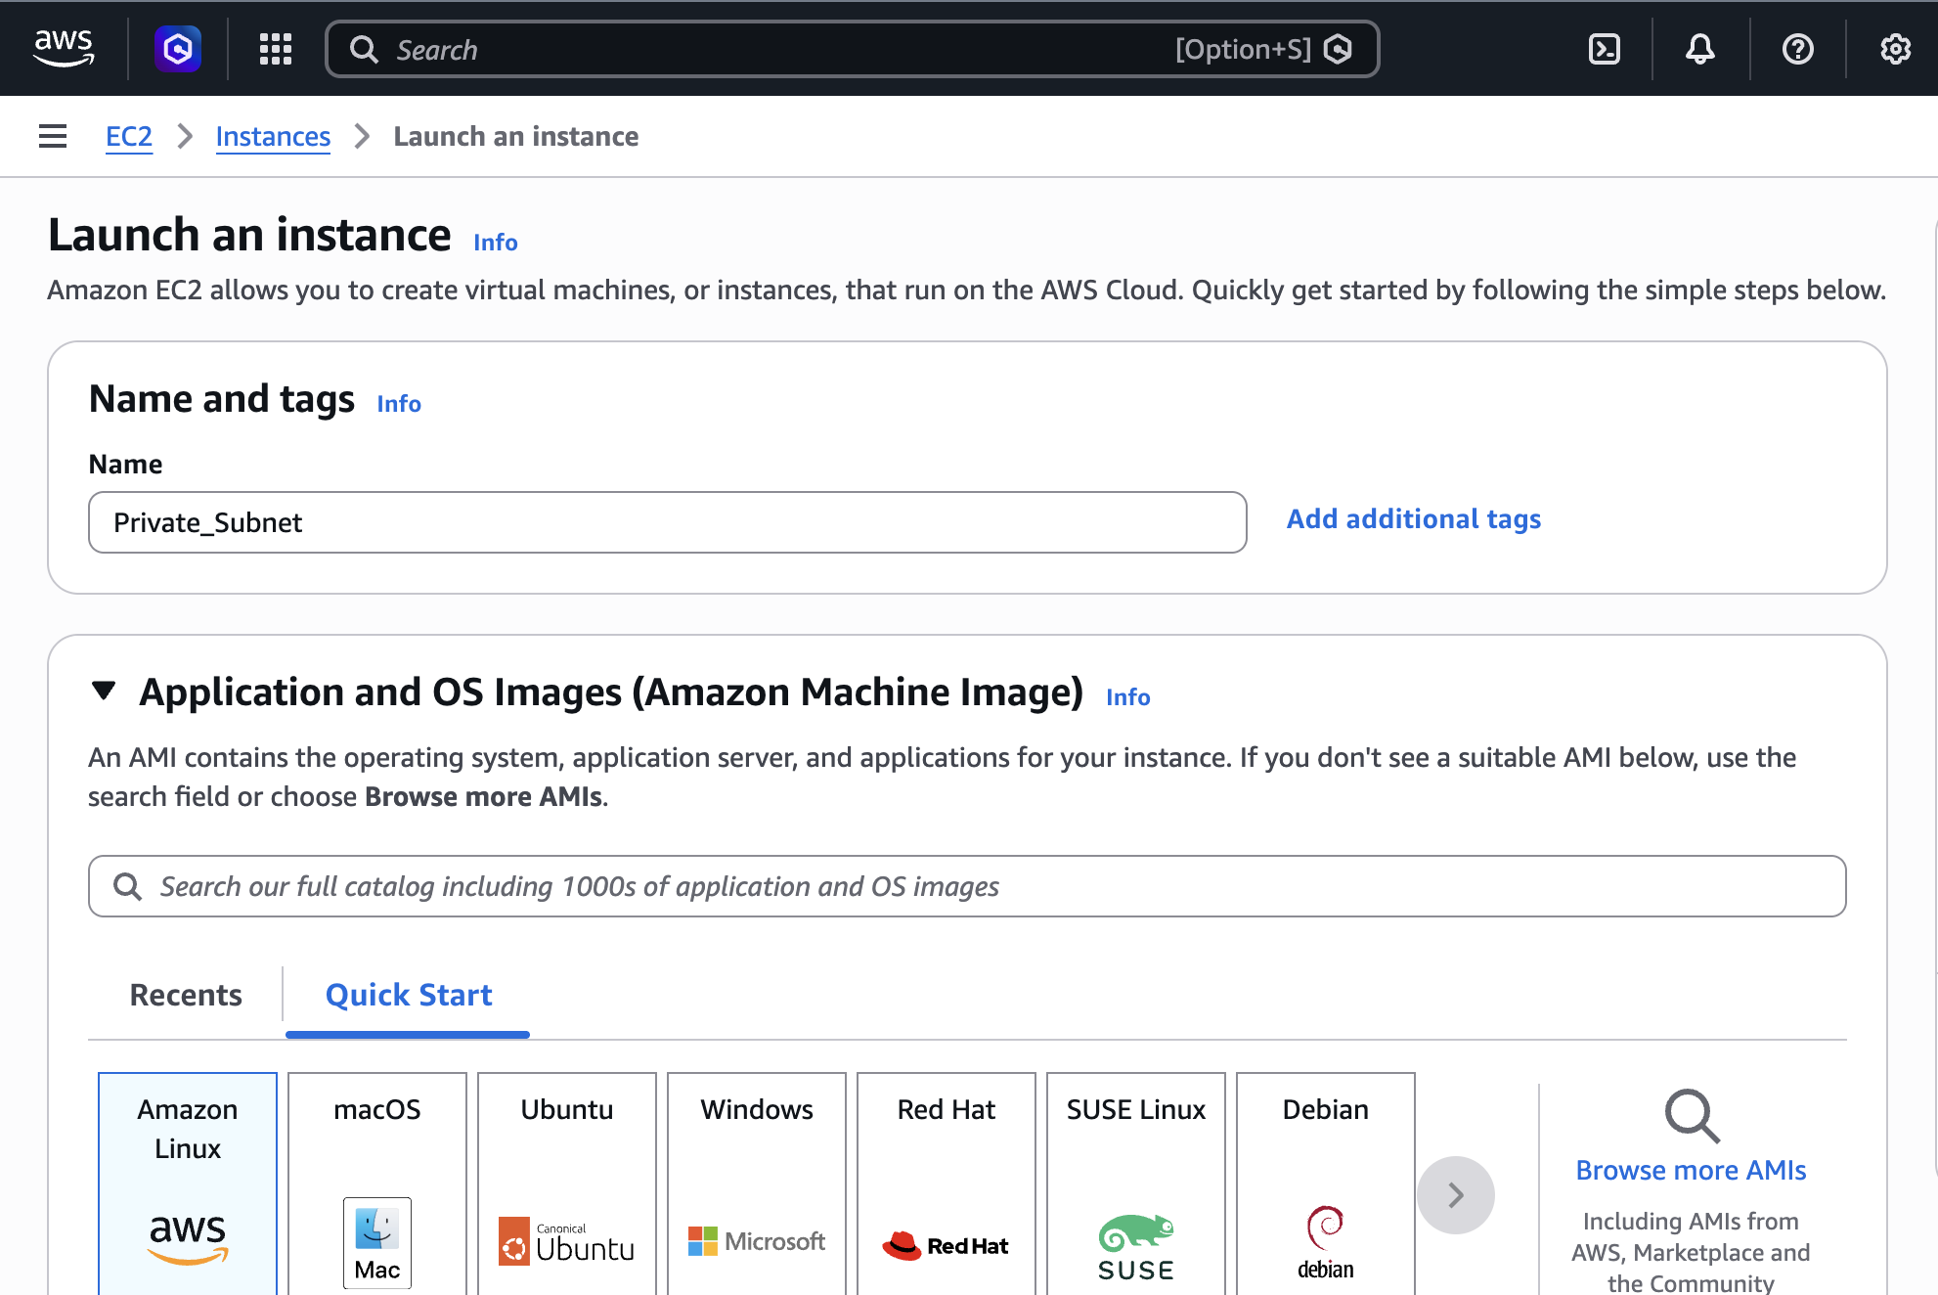
Select the VPC we created and Manually change the SubNet from Default Public to private from the Dropdown
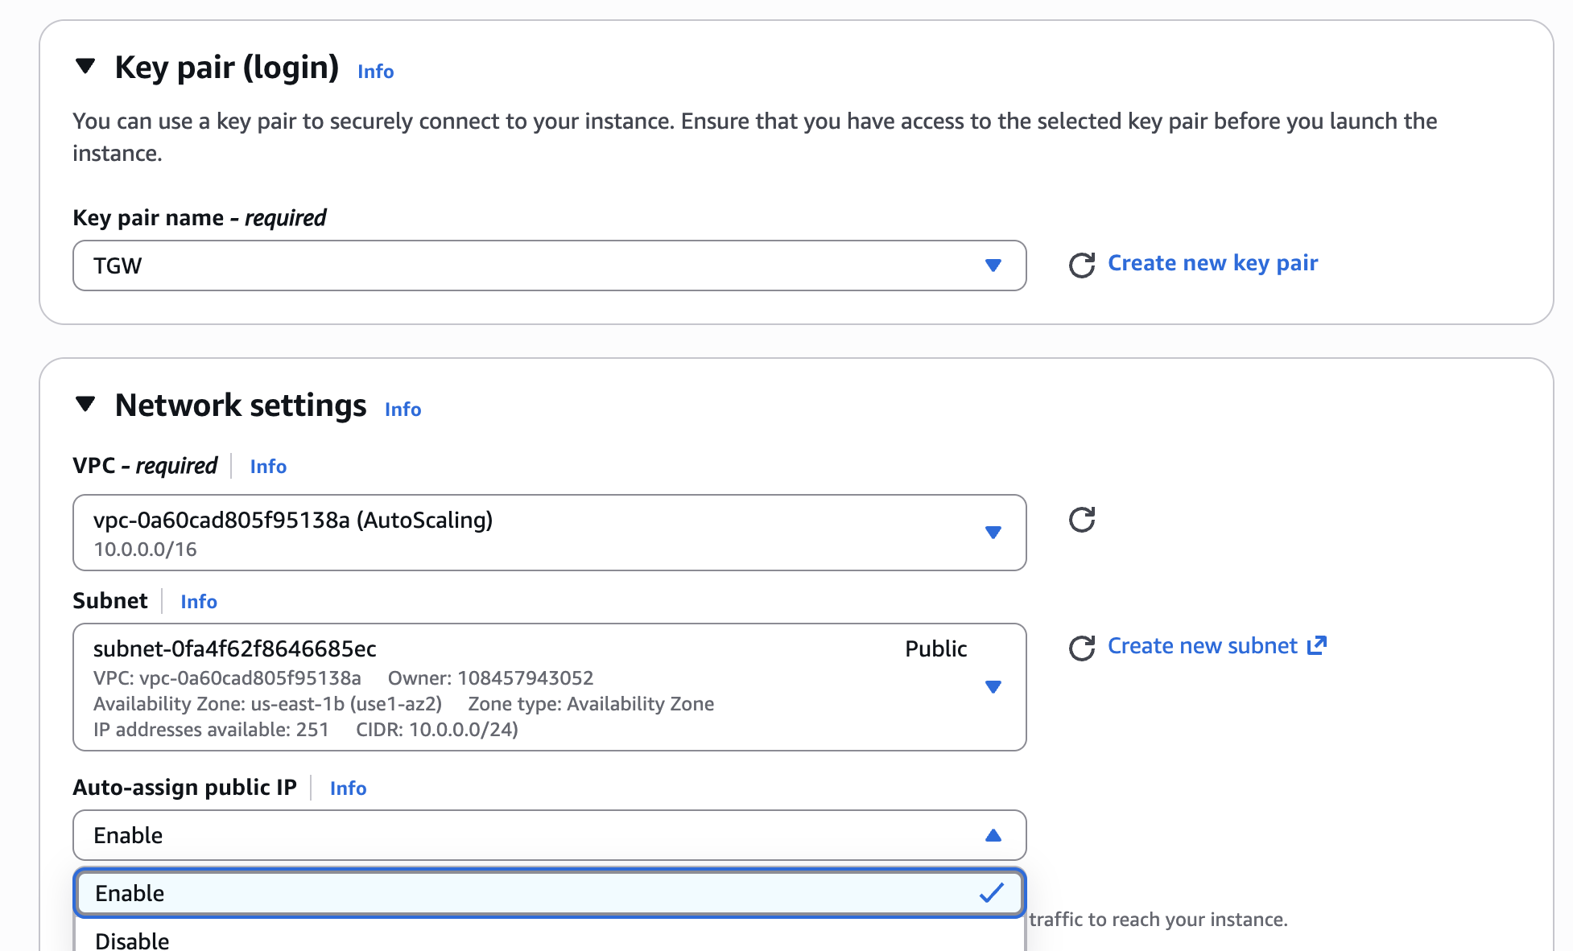
Now we have two EC2 Instances Created for Public and Private
and
Make sure Auto_assign Public IP is Enable as Below Screen Shot
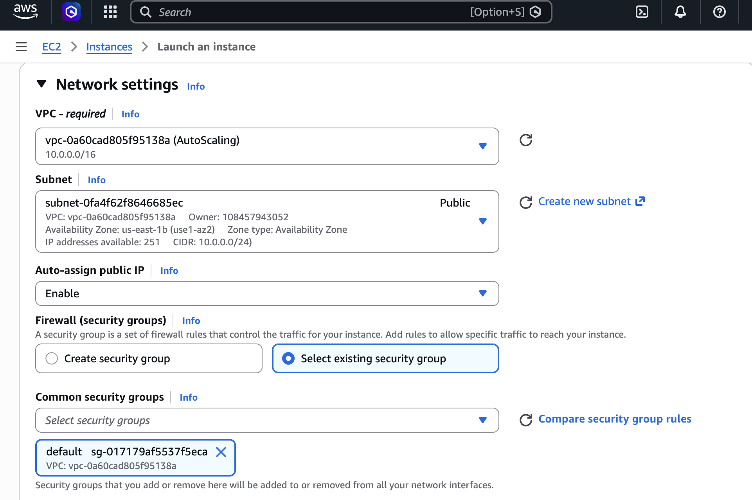
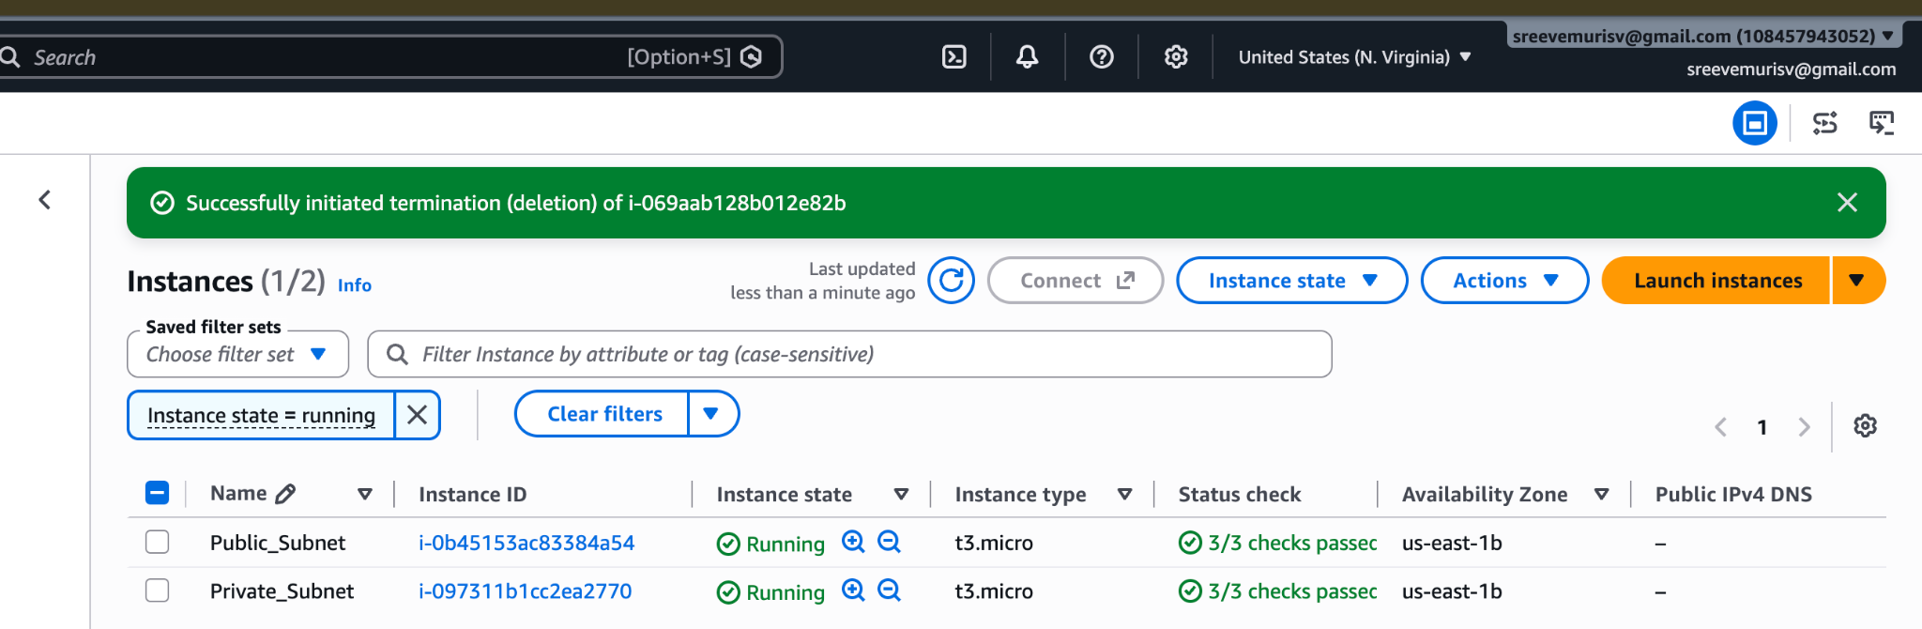
Deploy Apache server on both EC2 instances with a sample index.html file.
Public_subnet
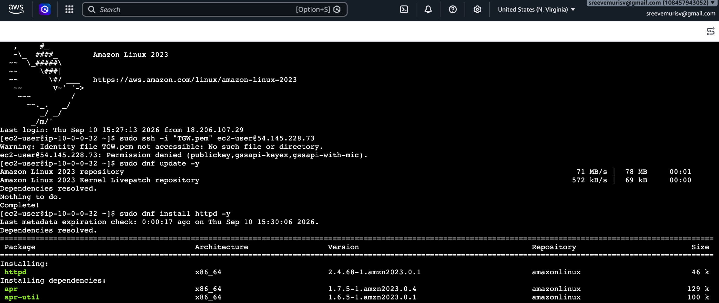
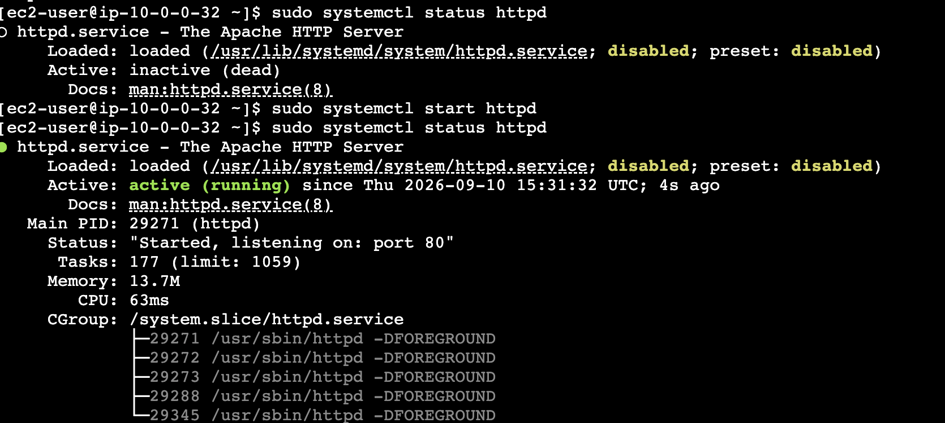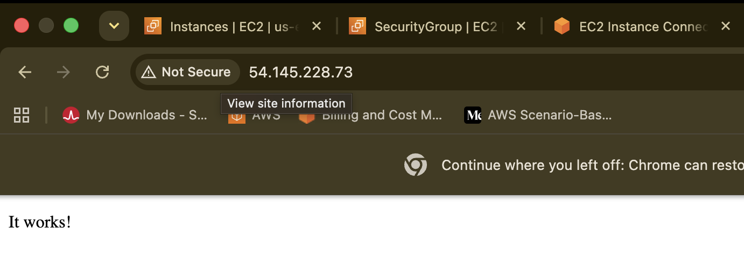
Now do the Jump srever
Make sure in VPC→ Rout Table → Private → check Subnet associate → edit → check private as below.
For private internet access for downloading Httpd
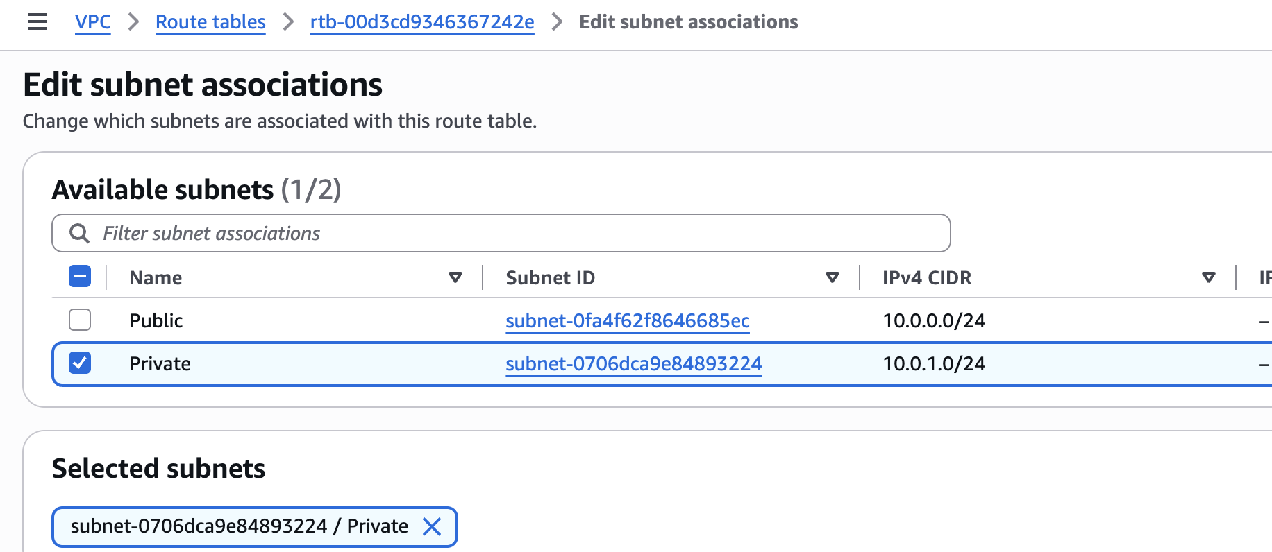
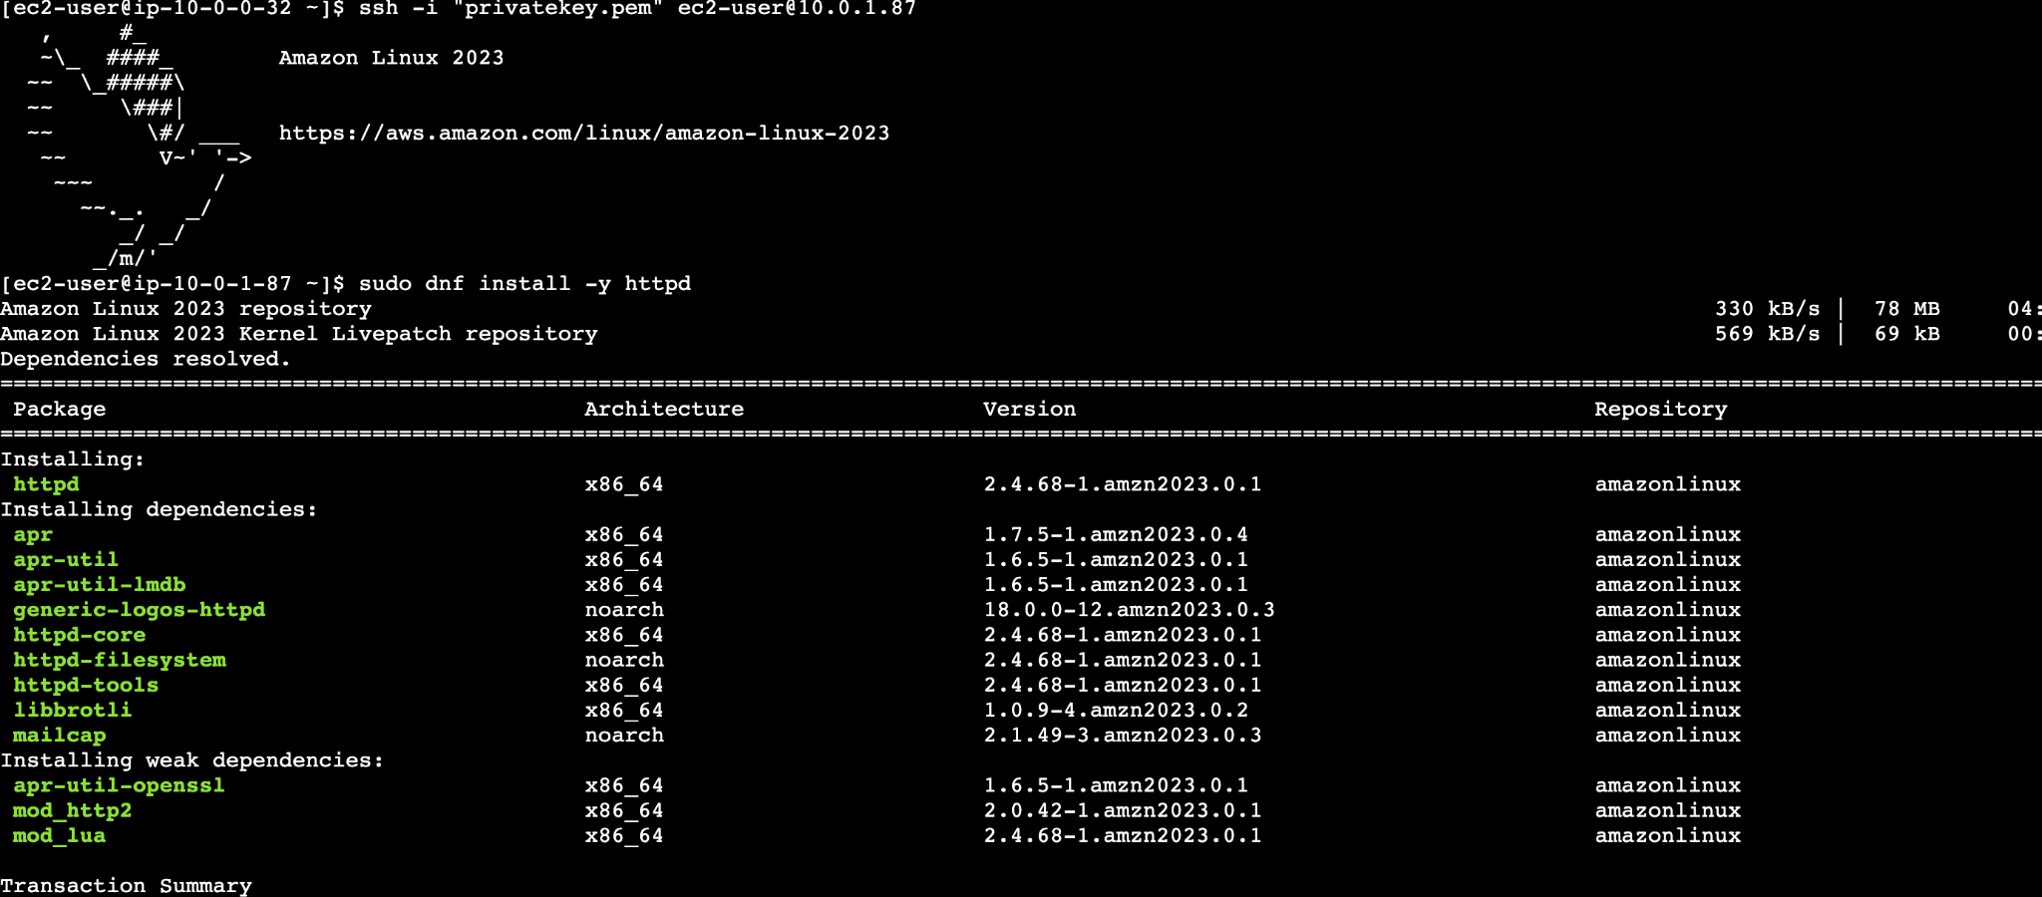
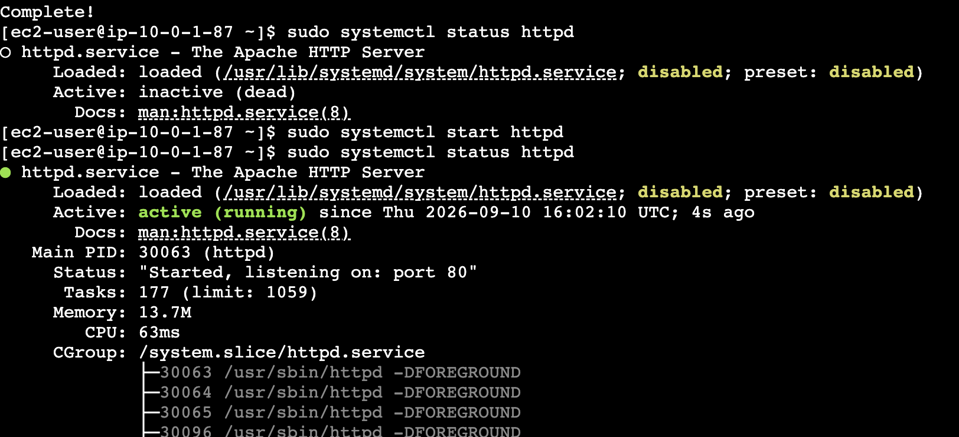
curl http://10.0.1.87 to see that page is running as we can see this in browser.

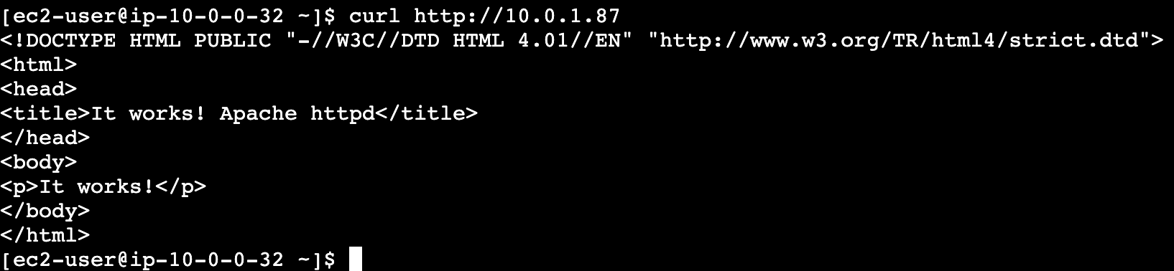
Create one application load balancer and attach it to both EC2 instances.
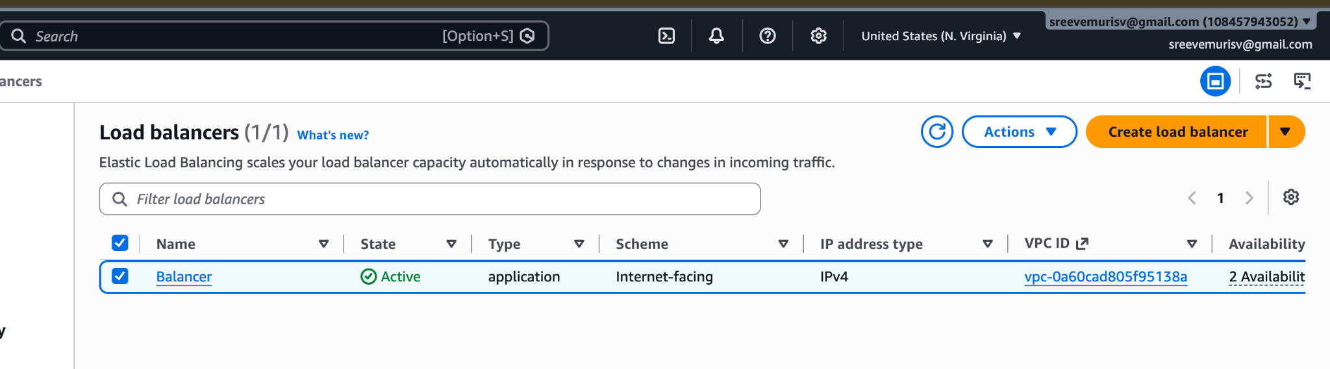
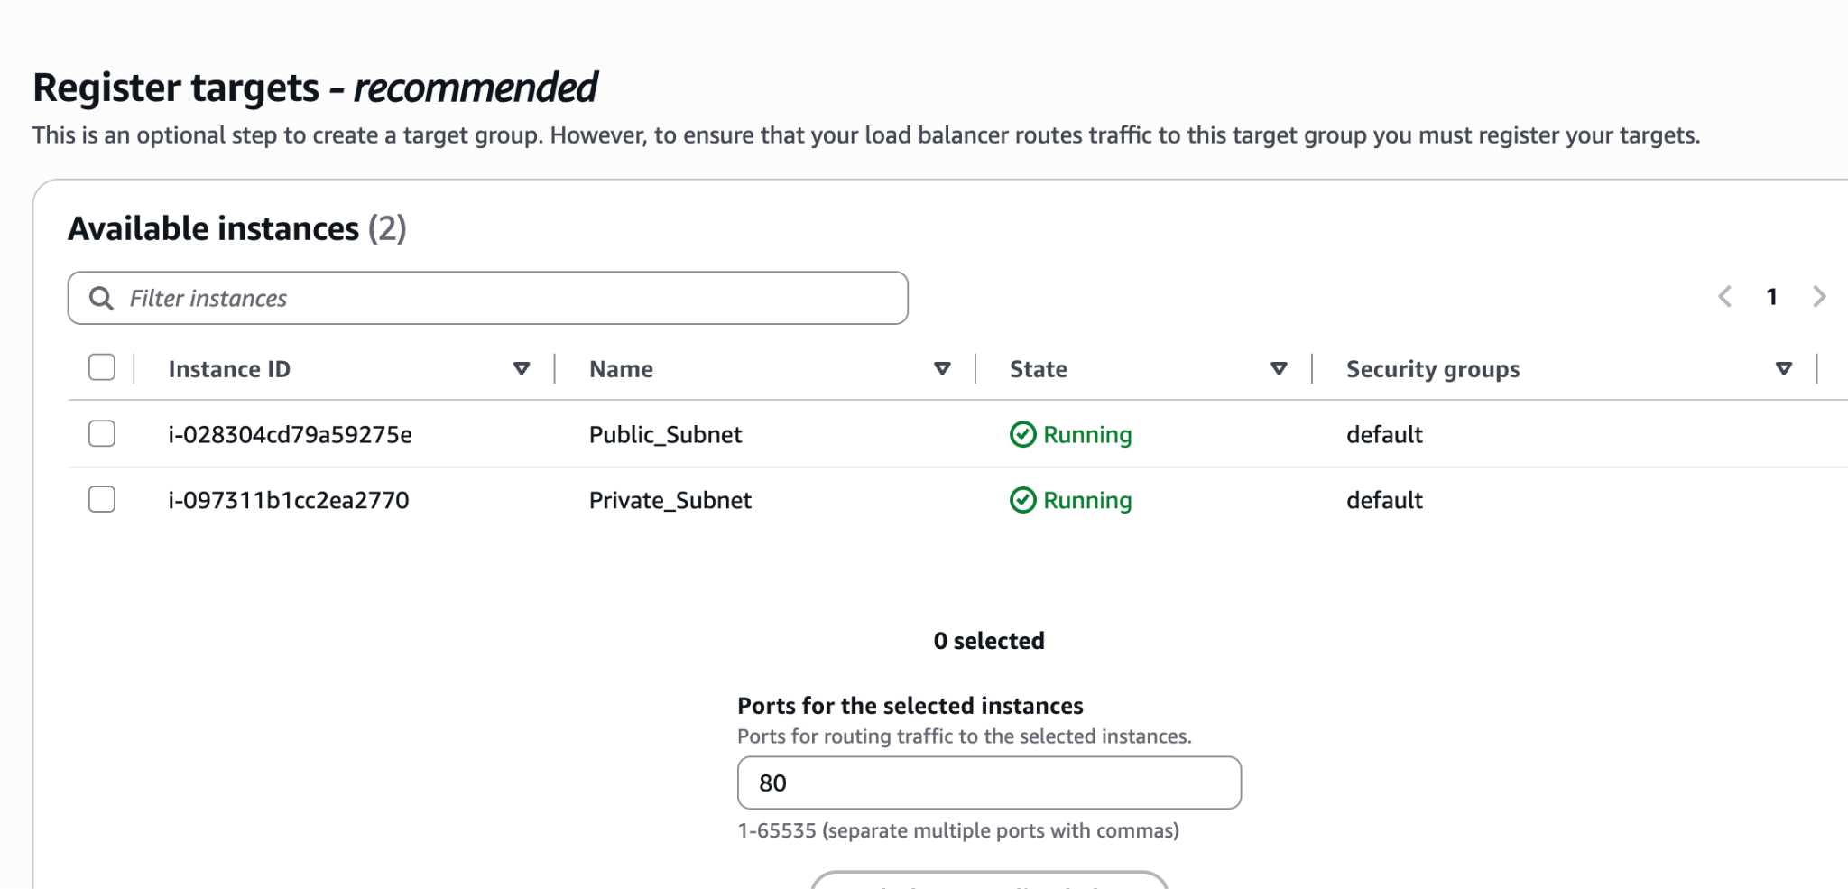
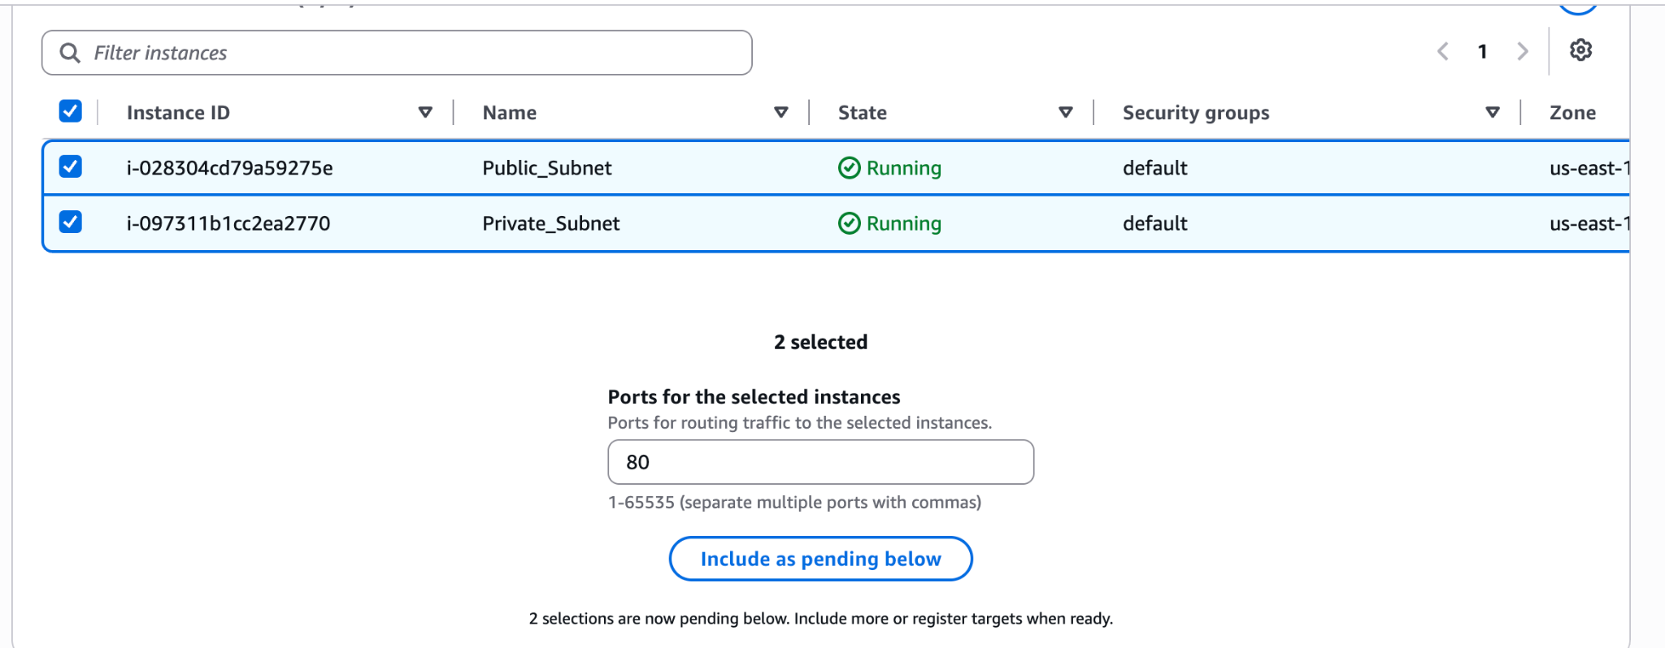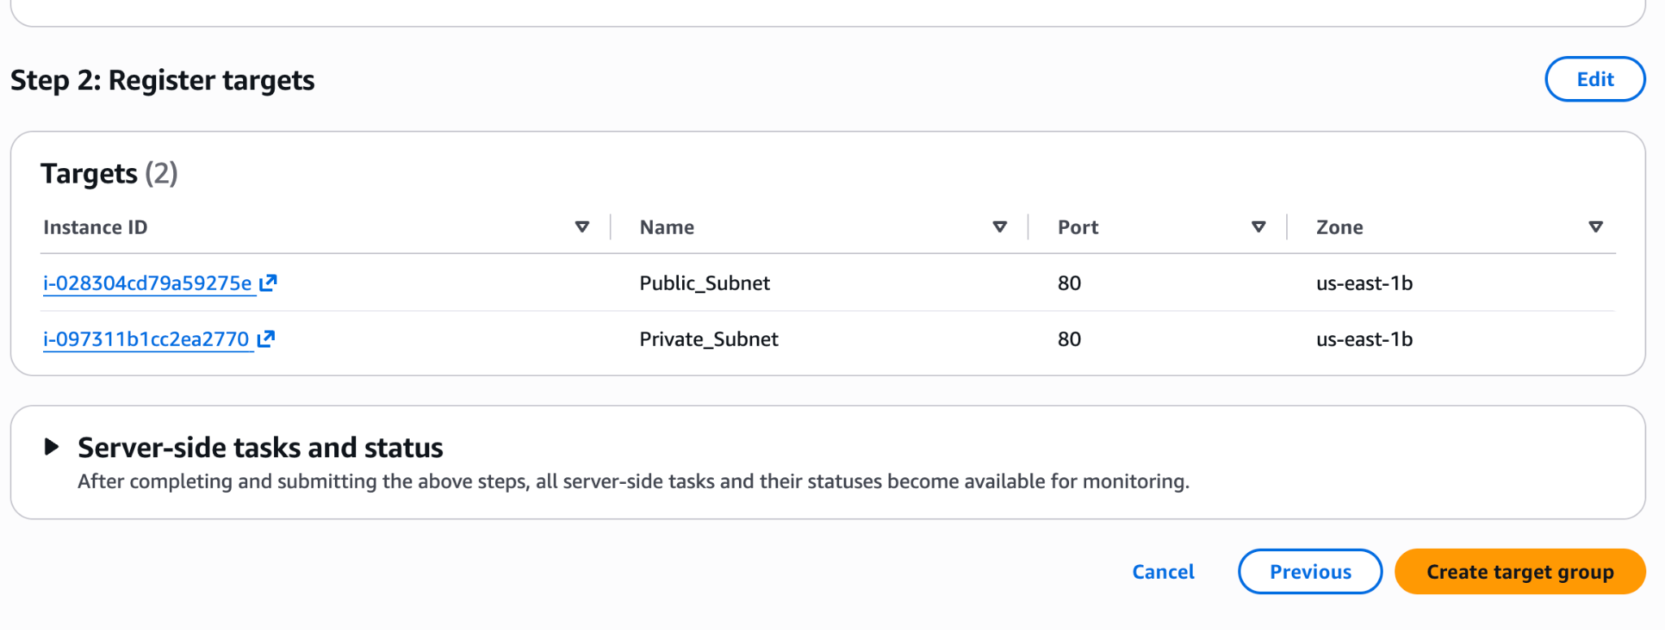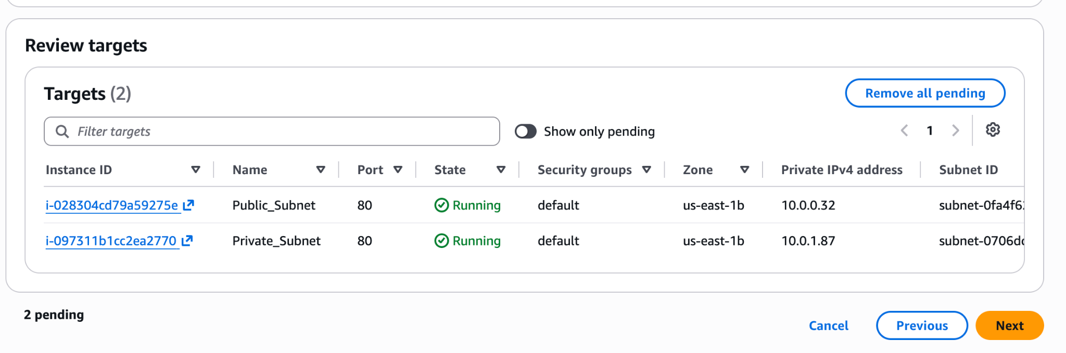
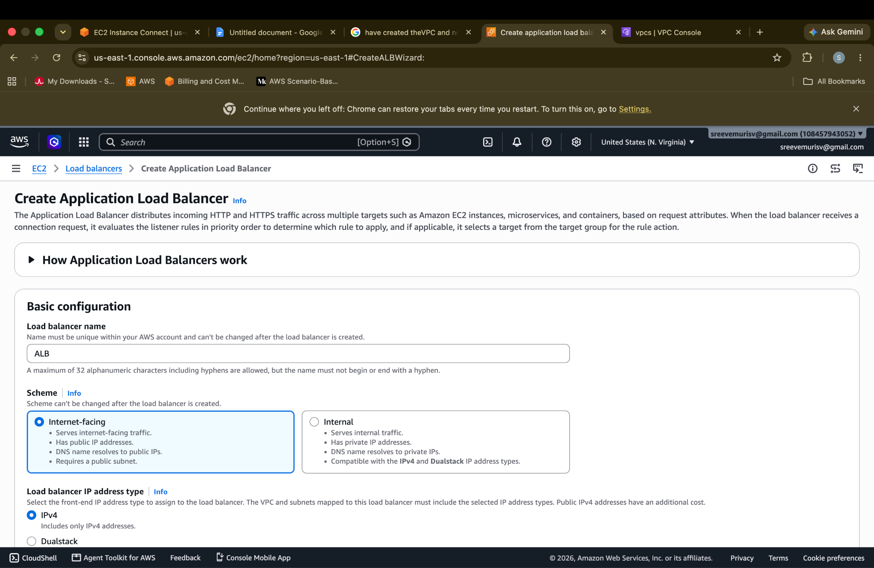
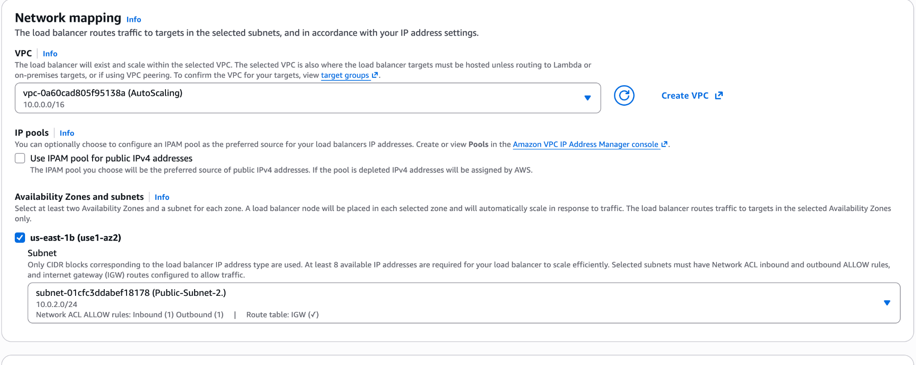
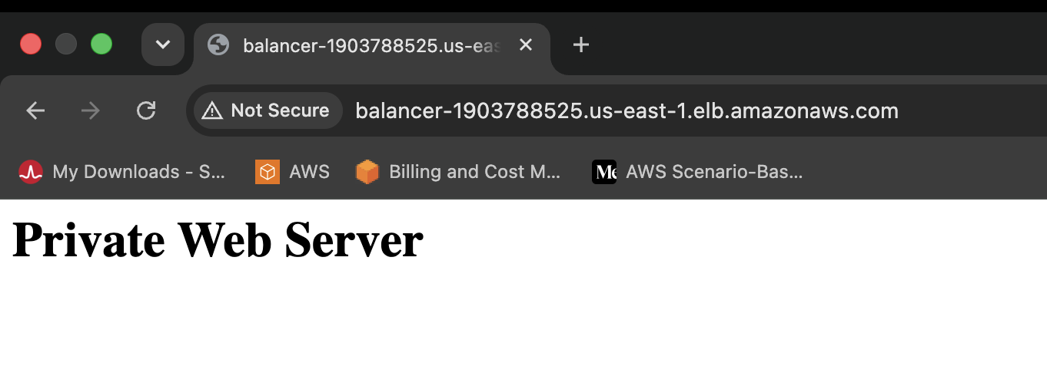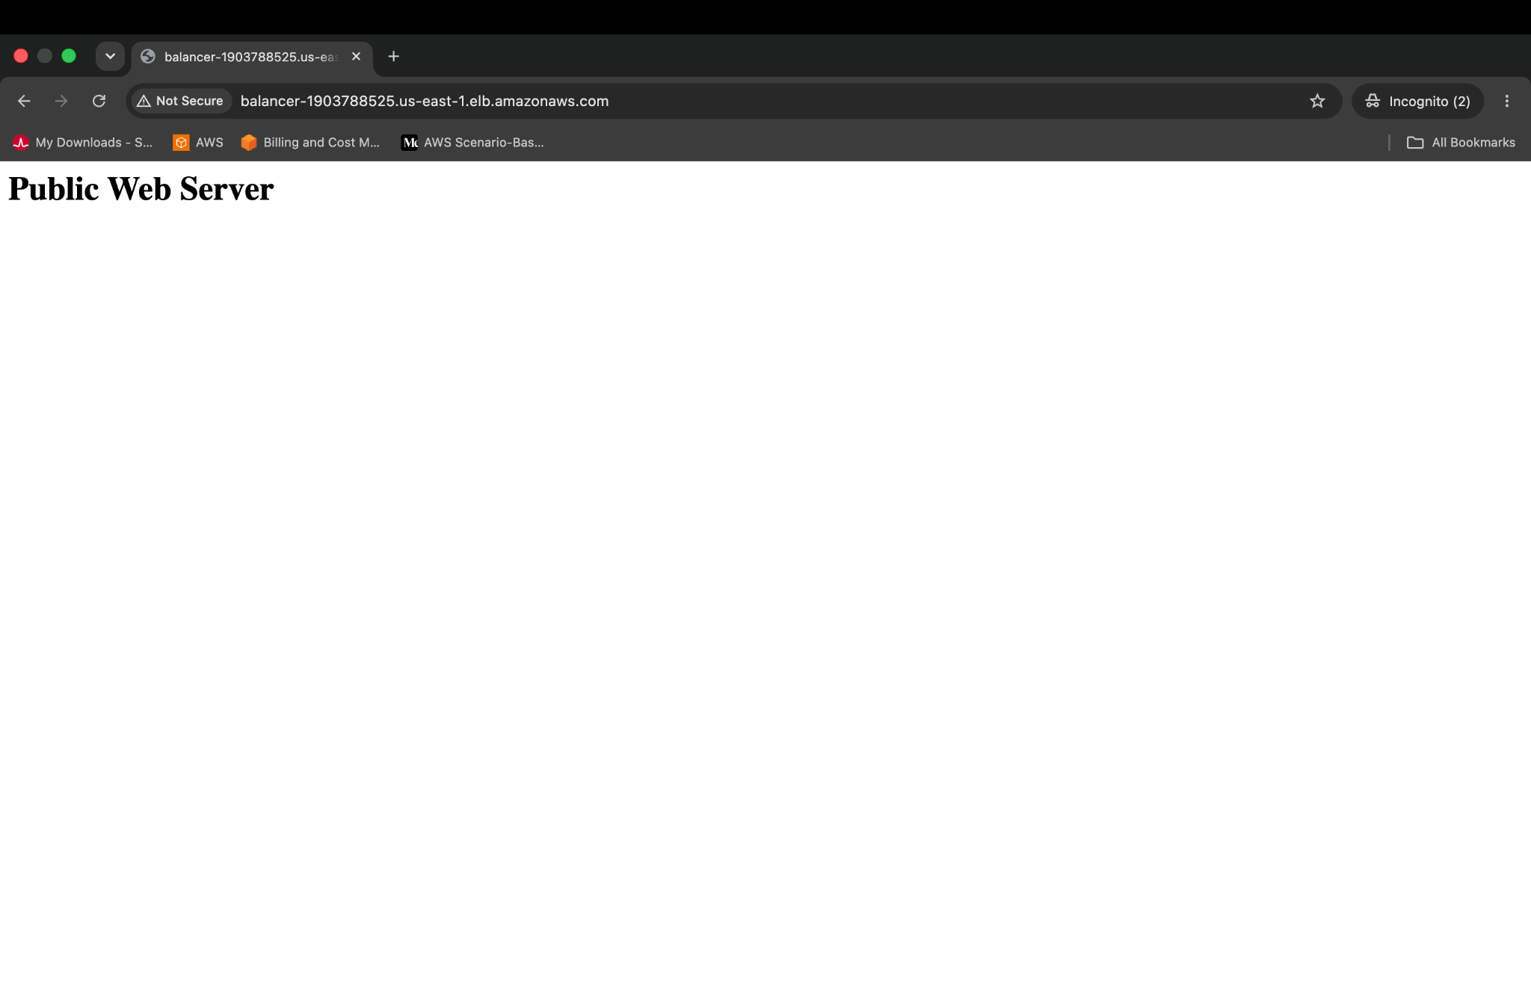
Store application load balancer logs in S3.
{
"Version": "2012-10-17",
"Statement": [
{
"Effect": "Allow",
"Principal": {
"AWS": "arn:aws:iam::127311923021:root"
},
"Action": "s3:PutObject",
"Resource": "arn:aws:s3:::autoscaling-s3bucket99/AWSLogs/*"
}
]
}
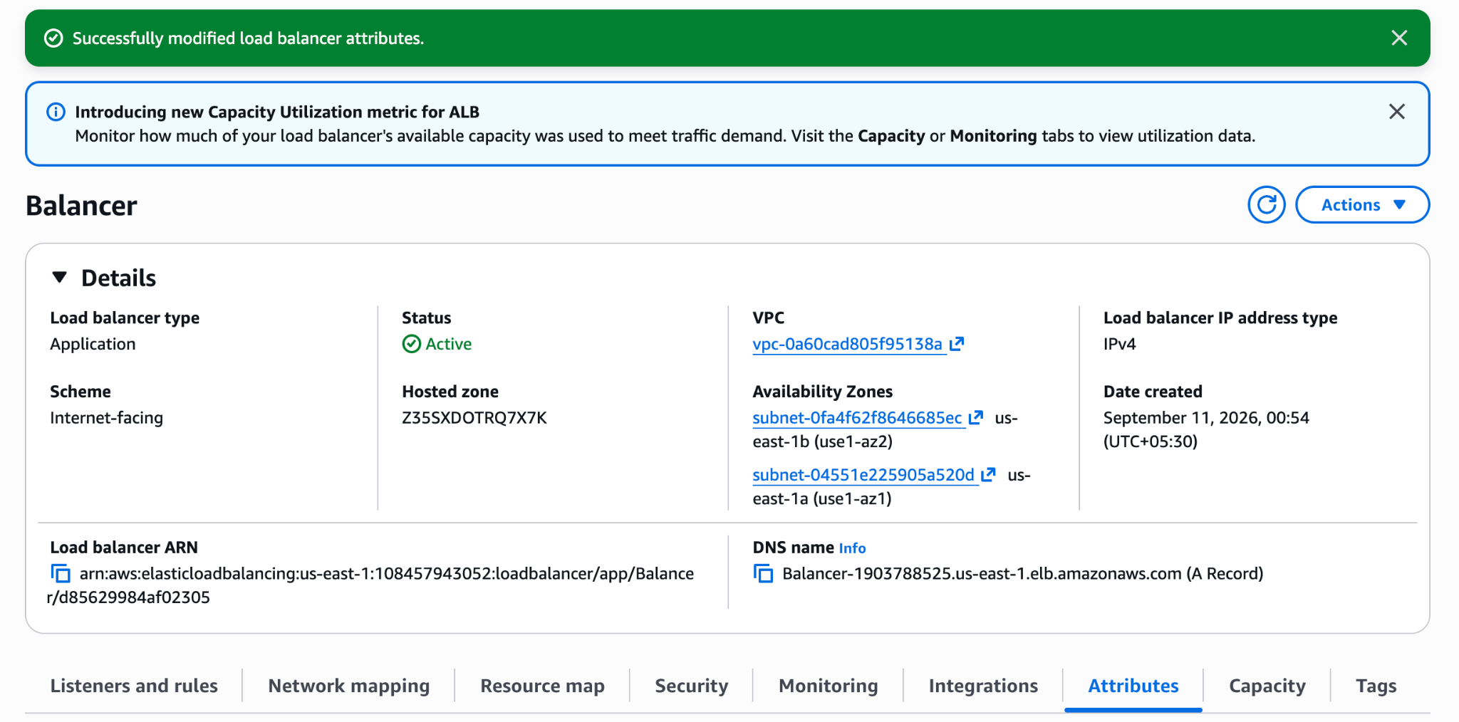
Store the VPC flow logs in a CloudWatch log group.
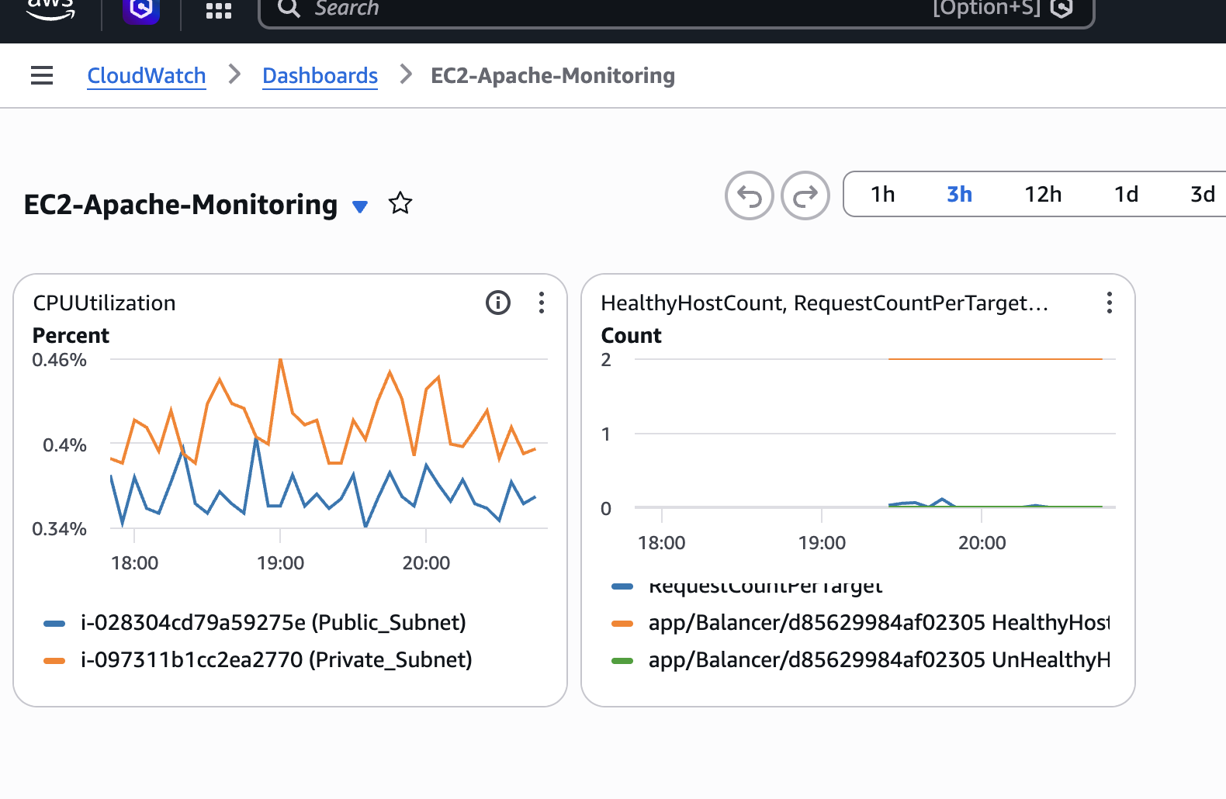
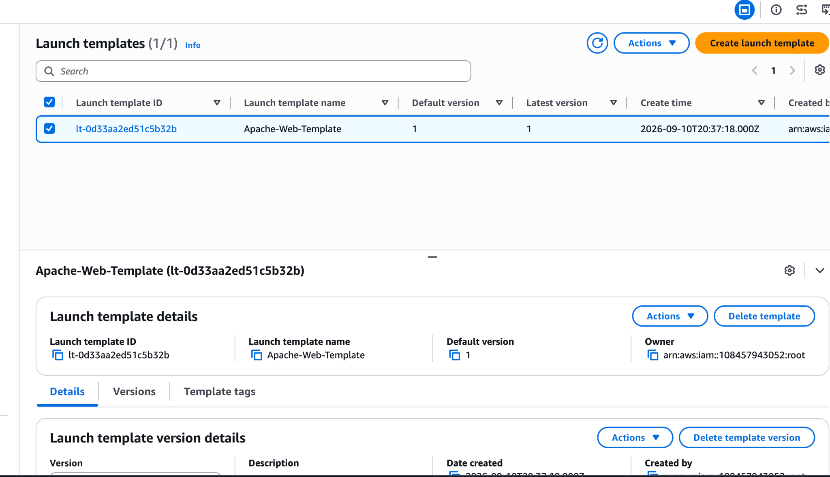
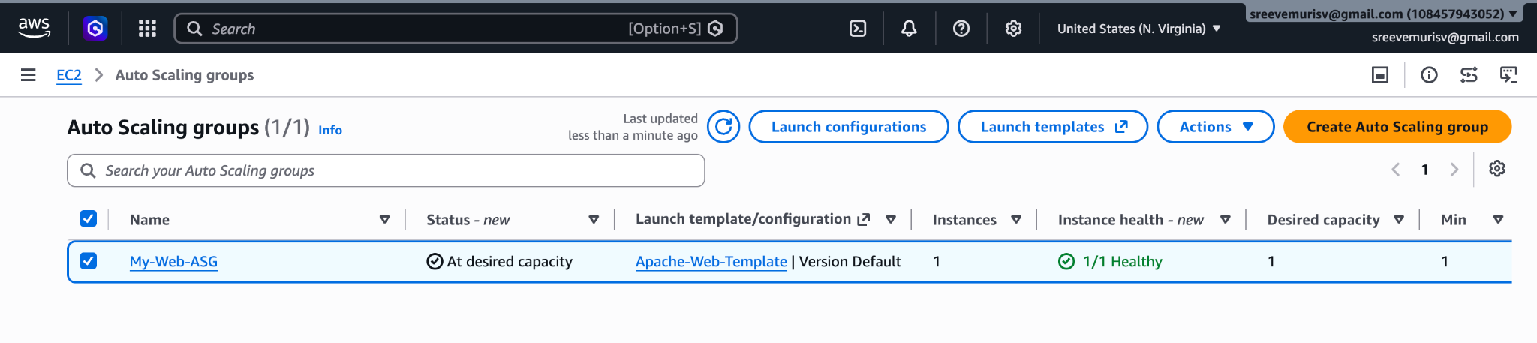

Phase 2: Security & Initial Web Servers (EC2)
- Configure Firewall Permissions:
  - Go to EC2 > Security Groups > Create security group. Name: Web-SG, VPC: Custom-VPC.
  - Inbound Rules:
    - Add HTTP (Port 80) from Source: 0.0.0.0/0.
    - Add SSH (Port 22) from Source: 0.0.0.0/0 (or your IP).
- Launch base EC2 Instances:
  - Public Server: Go to Instances > Launch instances. Name: Public-Server, Subnet: Public-1, Security Group: Web-SG. Assign a key pair (my-key.pem).
  - Private Server: Launch a second instance. Name: Private-Server, Subnet: Private-1, Security Group: Web-SG. Use the same key pair.
- Deploy Web Server Code:
  - SSH into Public-Server. Install Apache:
sudo dnf install httpd -y && sudo systemctl start httpd && sudo systemctl enable httpd
echo "<h1>Welcome to my Public EC2 Server!</h1>" | sudo tee /var/www/html/index.html

  - SSH from the public instance into Private-Server using your key. Run the same commands, but change the text:
echo "<h1>Hello from the Private EC2 Server!</h1>" | sudo tee /var/www/html/index.html

Phase 3: Traffic Distribution (Target Group & ALB)
- Build the Target Group:
  - Go to EC2 > Target Groups > Create target group.
  - Type: Instances, Name: My-Web-Targets, Protocol/Port: HTTP:80, VPC: Custom-VPC.
  - Click Next, check the boxes for both Public-Server and Private-Server, click Include as pending below, and hit Create.
- Deploy the Application Load Balancer:
  - Go to Load Balancers > Create load balancer > Application Load Balancer.
  - Name: My-Public-ALB, Scheme: Internet-facing. VPC: Custom-VPC.
  - Mappings: Check us-east-1a (select Subnet Public-1) AND check us-east-1b (select Subnet Public-2).
  - Security Groups: Select Web-SG.
  - Listeners & Routing: Route HTTP:80 to Default Action: My-Web-Targets. Click Create.

Phase 4: Network Observability (VPC Flow Logs)
- Set Up Destination Folder:
  - Go to CloudWatch > Log groups > Create log group. Name: /aws/vpc/custom-flow-logs.
- Establish Identity Permissions:
  - Go to IAM > Roles > Create role. Select Trusted Entity: AWS Service, Use Case: EC2. Click Next.
  - Attach policy: CloudWatchLogsFullAccess. Click Next.
  - Name it VPCFlowLogsRole and click Create.
  - Open VPCFlowLogsRole from your list, click the Trust relationships tab, hit Edit trust policy, swap "://amazonaws.com" to exactly "://amazonaws.com", and save.
- Activate Logging:
  - Return to VPC > Your VPCs, select Custom-VPC, click Actions > Create flow log.
  - Set Filter: ALL, Destination: Send to CloudWatch Logs, Log Group: /aws/vpc/custom-flow-logs, IAM Role: VPCFlowLogsRole. Click Create.

Phase 5: Self-Healing Automation (Auto Scaling)
- Create the Server Blueprint:
  - Go to EC2 > Launch Templates > Create launch template.
  - Name: Apache-Blueprint, AMI: Amazon Linux 2023, Instance Type: t2.micro, Key Pair: my-key.pem, Security Group: Web-SG.
  - Expand Advanced details, scroll to the very bottom User data box, and paste the automated boot script:
#!/bin/bash
dnf update -y
dnf install httpd -y
systemctl start httpd
systemctl enable httpd
echo "<h1>Hello from a newly Auto-Scaled Server!</h1>" > /var/www/html/index.html

  - Click Create launch template.
- Deploy the Auto Scaling Group (ASG):
  - Go to Auto Scaling Groups > Create Auto Scaling group.
  - Name: My-Web-ASG, Launch Template: Apache-Blueprint. Click Next.
  - Network: VPC: Custom-VPC, Subnets: Select Private-1. Click Next.
  - Load Balancing: Select Attach to an existing load balancer, click Choose from your load balancer target groups, and select My-Web-Targets. Click Next.
- Configure the >70% CPU Metric Rule:
  - Group Size: Desired: 1, Minimum: 1, Maximum: 3.
  - Scaling Policies: Select Target tracking scaling policy.
  - Metric type: Average CPU utilization.
  - Target value: Type exactly 70.
  - Complete the wizard steps and click Create Auto Scaling group.

Phase 6: Operational Verification & Clean Up
- Test Infrastructure Live:
  - Go to EC2 > Load Balancers, select My-Public-ALB, copy its long DNS Name, and paste it into a fresh web browser tab.
  - Refresh the page continuously to watch it distribute traffic dynamically across your infrastructure.
- Prevent Cloud Bills (Teardown Sequence):
  - Delete My-Web-ASG (this safely shuts down all automated ec2 instances first).
  - Delete My-Public-ALB.
  - Terminate your manually created Public-Server and Private-Server instances.
  - Delete My-NAT gateway, then release its associated Elastic IP from your account.
Are you looking to save this exact guide as a text file blueprint for your future reference, or would you like to build an advanced infrastructure diagram architecture next?

